Justin Guerra
Data Mining
Project 2.1

Summary Statistics

Temperature

Minimum: 64
Maximum: 85
Average: 73.571
StdDev: 6.572

Humidity

Minimum: 65
Maximum: 96
Average: 81.643
StdDev: 10.285

Clustering

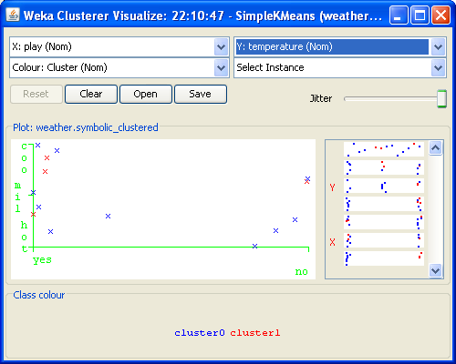

This is one of my more interesting clusters, although it doesn’t show very much. I couldn’t find anything with much meaning. It seems that golfers like to golf regardless of weather conditions. They do prefer cool weather to hot weather though.

J48 Decision Tree

The decision tree built, based on the attribute playing was correct 50% of the time, which was worse than ZeroR at 64.29%.

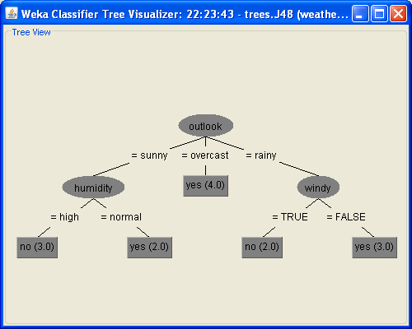

Rule Based Classifiers
The API didn’t seem to offer very thorough descriptions of the different algorithms.

DecisionTable

DecisionTable generates a decision table classifier. Decision Tables are a simple, yet powerful tool for supervised learning algorithms. I have to pay for the rest of the paper referenced by the API.

=== Run information ===

Scheme: weka.classifiers.rules.DecisionTable -X 1 -S "weka.attributeSelection.BestFirst -D 1 -N 5"
Relation: weather.symbolic
Instances: 14
Attributes: 5
outlook
temperature
humidity
windy
play
Test mode: 10-fold cross-validation

=== Classifier model (full training set) ===

Decision Table:

Number of training instances: 14
Number of Rules : 1
Non matches covered by Majority class.
Best first.
Start set: no attributes
Search direction: forward
Stale search after 5 node expansions
Total number of subsets evaluated: 12
Merit of best subset found: 64.286
Evaluation (for feature selection): CV (leave one out)
Feature set: 5

Time taken to build model: 0 seconds

=== Stratified cross-validation ===
=== Summary ===

Correctly Classified Instances 6 42.8571 %
Incorrectly Classified Instances 8 57.1429 %
Kappa statistic -0.3659
Mean absolute error 0.5318
Root mean squared error 0.5583
Relative absolute error 111.6786 %
Root relative squared error 113.1584 %
Total Number of Instances 14

=== Detailed Accuracy By Class ===

TP Rate FP Rate Precision Recall F-Measure ROC Area Class
0.667 1 0.545 0.667 0.6 0.289 yes
0 0.333 0 0 0 0.289 no
Weighted Avg. 0.429 0.762 0.351 0.429 0.386 0.289

=== Confusion Matrix ===

a b <-- classified as
6 3 | a = yes
5 0 | b = no

JRip

JRip is a propositional rule learner. It works by growing a tree until a rule is 100% correct, it does this by trying every possible value of each attribute and uses the value with the highest information gain. The next step of the algorithm prunes the rules. These two stages are repeated until the error rate is >= 50%. The rules are then optimized and cleaned up.

=== Run information ===

Scheme: weka.classifiers.rules.JRip -F 3 -N 2.0 -O 2 -S 1
Relation: weather.symbolic
Instances: 14
Attributes: 5
outlook
temperature
humidity
windy
play
Test mode: 10-fold cross-validation

=== Classifier model (full training set) ===

JRIP rules:
===========

(humidity = high) and (outlook = sunny) => play=no (3.0/0.0)
(outlook = rainy) and (windy = TRUE) => play=no (2.0/0.0)
=> play=yes (9.0/0.0)

Number of Rules : 3

Time taken to build model: 0 seconds

=== Stratified cross-validation ===
=== Summary ===

Correctly Classified Instances 9 64.2857 %
Incorrectly Classified Instances 5 35.7143 %
Kappa statistic 0.186
Mean absolute error 0.3674
Root mean squared error 0.5338
Relative absolute error 77.1635 %
Root relative squared error 108.1927 %
Total Number of Instances 14

=== Detailed Accuracy By Class ===

TP Rate FP Rate Precision Recall F-Measure ROC Area Class
0.778 0.6 0.7 0.778 0.737 0.656 yes
0.4 0.222 0.5 0.4 0.444 0.656 no
Weighted Avg. 0.643 0.465 0.629 0.643 0.632 0.656

=== Confusion Matrix ===

a b <-- classified as
7 2 | a = yes
3 2 | b = no

ZeroR

ZeroR predicts the mode, which is why its accuracy is directly relatated to the biggest percentage in the given category. For example, in this data set play is yes 64% of the time, the same as ZeroR’s accuracy rate.

=== Run information ===

Scheme: weka.classifiers.rules.ZeroR
Relation: weather.symbolic
Instances: 14
Attributes: 5
outlook
temperature
humidity
windy
play
Test mode: 10-fold cross-validation

=== Classifier model (full training set) ===

ZeroR predicts class value: yes

Time taken to build model: 0 seconds

=== Stratified cross-validation ===
=== Summary ===

Correctly Classified Instances 9 64.2857 %
Incorrectly Classified Instances 5 35.7143 %
Kappa statistic 0
Mean absolute error 0.4762
Root mean squared error 0.4934
Relative absolute error 100 %
Root relative squared error 100 %
Total Number of Instances 14

=== Detailed Accuracy By Class ===

TP Rate FP Rate Precision Recall F-Measure ROC Area Class
1 1 0.643 1 0.783 0.178 yes
0 0 0 0 0 0.178 no
Weighted Avg. 0.643 0.643 0.413 0.643 0.503 0.178

=== Confusion Matrix ===

a b <-- classified as
9 0 | a = yes
5 0 | b = no

Nearest Neighbor

NNge was quite a bit more accurate than the other rule based classifiers. NNge was also more accurate than KStar. One interesting thing I found with KStar was that setting globalblend=2 was the minimum size required to get the max accuracy. IB 1 had the lowest accuracy of 50%. IB k had the same accuracy as KStar with the default KNN = 1. I was able to increase the accuracy to ~64% by increasing KNN. Changing the other options, including the nearest neighbor search algorithm and distance metric had no impact on my results.

NNge

=== Run information ===

Scheme: weka.classifiers.rules.NNge -G 5 -I 5
Relation: weather.symbolic
Instances: 14
Attributes: 5
outlook
temperature
humidity
windy
play
Test mode: 10-fold cross-validation

=== Classifier model (full training set) ===

NNGE classifier

Rules generated :
class no IF : outlook in {rainy} ^ temperature in {mild,cool} ^ humidity in {high,normal} ^ windy in {TRUE} (2)
class yes IF : outlook in {overcast,rainy} ^ temperature in {hot,mild,cool} ^ humidity in {high,normal} ^ windy in {FALSE} (5)
class yes IF : outlook in {overcast} ^ temperature in {mild,cool} ^ humidity in {high,normal} ^ windy in {TRUE} (2)
class yes IF : outlook in {sunny} ^ temperature in {mild,cool} ^ humidity in {normal} ^ windy in {TRUE,FALSE} (2)
class no IF : outlook in {sunny} ^ temperature in {hot,mild} ^ humidity in {high} ^ windy in {TRUE,FALSE} (3)

Stat :
class yes : 3 exemplar(s) including 3 Hyperrectangle(s) and 0 Single(s).
class no : 2 exemplar(s) including 2 Hyperrectangle(s) and 0 Single(s).

Total : 5 exemplars(s) including 5 Hyperrectangle(s) and 0 Single(s).

Feature weights : [0.24674981977443894 0.029222565658954577 0.15183550136234153 0.04812703040826924]

Time taken to build model: 0 seconds

=== Stratified cross-validation ===
=== Summary ===

Correctly Classified Instances 11 78.5714 %
Incorrectly Classified Instances 3 21.4286 %
Kappa statistic 0.5116
Mean absolute error 0.2143
Root mean squared error 0.4629
Relative absolute error 45 %
Root relative squared error 93.8273 %
Total Number of Instances 14

=== Detailed Accuracy By Class ===

TP Rate FP Rate Precision Recall F-Measure ROC Area Class
0.889 0.4 0.8 0.889 0.842 0.744 yes
0.6 0.111 0.75 0.6 0.667 0.744 no
Weighted Avg. 0.786 0.297 0.782 0.786 0.779 0.744

=== Confusion Matrix ===

a b <-- classified as
8 1 | a = yes
2 3 | b = no

IB 1
=== Run information ===

Scheme: weka.classifiers.lazy.IB1
Relation: weather.symbolic
Instances: 14
Attributes: 5
outlook
temperature
humidity
windy
play
Test mode: 10-fold cross-validation

=== Classifier model (full training set) ===

IB1 classifier

Time taken to build model: 0 seconds

=== Stratified cross-validation ===
=== Summary ===

Correctly Classified Instances 7 50 %
Incorrectly Classified Instances 7 50 %
Kappa statistic 0.0392
Mean absolute error 0.5
Root mean squared error 0.7071
Relative absolute error 105 %
Root relative squared error 143.3236 %
Total Number of Instances 14

=== Detailed Accuracy By Class ===

TP Rate FP Rate Precision Recall F-Measure ROC Area Class
0.444 0.4 0.667 0.444 0.533 0.522 yes
0.6 0.556 0.375 0.6 0.462 0.522 no
Weighted Avg. 0.5 0.456 0.563 0.5 0.508 0.522

=== Confusion Matrix ===

a b <-- classified as
4 5 | a = yes
2 3 | b = no

IB k

=== Run information ===

Scheme: weka.classifiers.lazy.IBk -K 100 -W 0 -A "weka.core.neighboursearch.LinearNNSearch -A \"weka.core.EuclideanDistance -R first-last\""
Relation: weather.symbolic
Instances: 14
Attributes: 5
outlook
temperature
humidity
windy
play
Test mode: 10-fold cross-validation

=== Classifier model (full training set) ===

IB1 instance-based classifier
using 100 nearest neighbour(s) for classification

Time taken to build model: 0 seconds

=== Stratified cross-validation ===
=== Summary ===

Correctly Classified Instances 9 64.2857 %
Incorrectly Classified Instances 5 35.7143 %
Kappa statistic 0
Mean absolute error 0.4728
Root mean squared error 0.4955
Relative absolute error 99.2982 %
Root relative squared error 100.4318 %
Total Number of Instances 14

=== Detailed Accuracy By Class ===

TP Rate FP Rate Precision Recall F-Measure ROC Area Class
1 1 0.643 1 0.783 0.178 yes
0 0 0 0 0 0.178 no
Weighted Avg. 0.643 0.643 0.413 0.643 0.503 0.178

=== Confusion Matrix ===

a b <-- classified as
9 0 | a = yes
5 0 | b = no

